NC Sandhills Conservation Partnership- Land Protection Workgroup update 3/17/2021
Since the last meeting December 2, 2020 there has been the following Land Protection activity:
- The Town of Southern Pines purchased the ~157 acre Whitehall property in Southern Pines. The property includes an existing 67 acre conservation easement held by Three Rivers Land Trust. As part of the recent transaction, the Town placed a conservation easement on an additional 9 acres with Three Rivers. The deal also included deed restrictions on subdividing the property or commercial or residential development.
- The Nature Conservancy sold the 107 Buckrub property to the NC Wildlife Resources Commission on 12/15/20. This property is now part of Sandhills Game Land and the land sale proceeds will be used to purchase additional land in the Sandhills.
- TNC and 3R continue to work on multiple projects that are in various stages

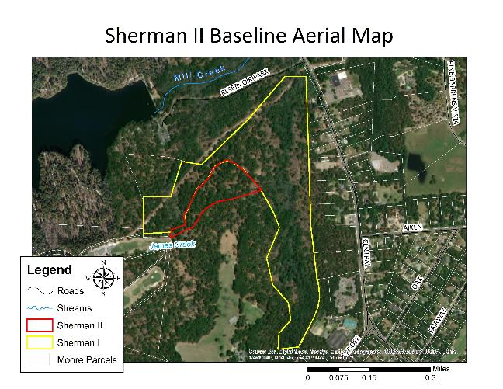
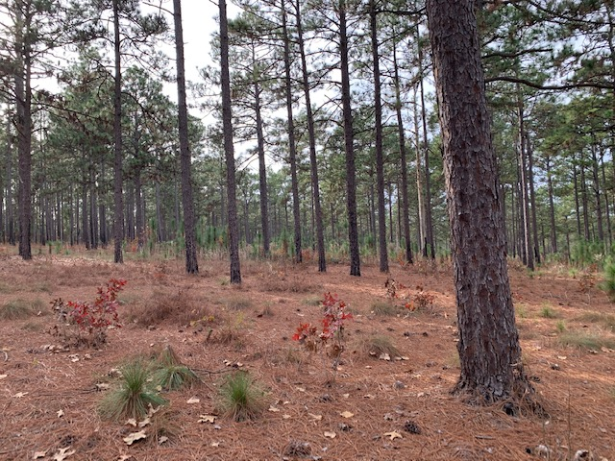
Longleaf habitat on the Whitehall easement

